Marcus Hernandez
COMSC-078, Section 202
Sep 5 2026
Functions - Assignment 2
Program 1: Statistical Functions
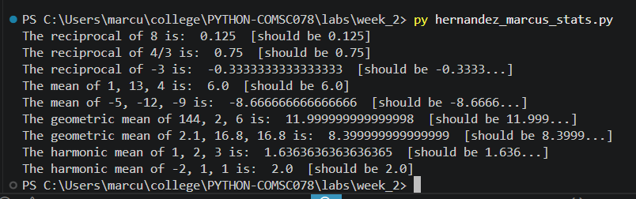

Program 2: Decimal Degrees
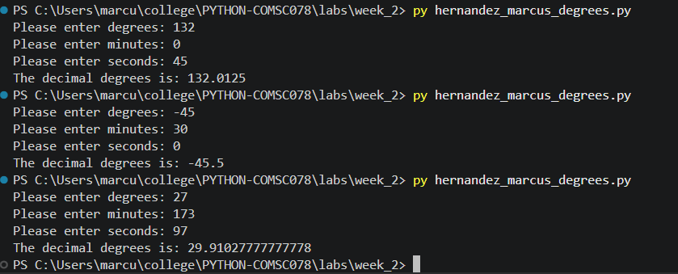

Program 3: Phone Plan
